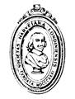 | 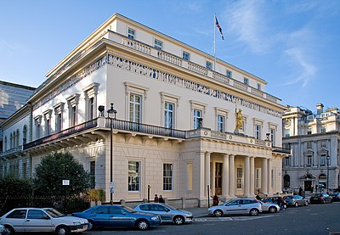 | THE HARVEIAN SOCIETY OF LONDON  FOUNDED 1831  LETTSOM HOUSE  11 CHANDOS STREET,  LONDON, WIG 9EB  Telephone: 020 7580 1043  Fax: 020 7580 5793  harveiansoclondon@outlook.com

Dear Member

HARVEIAN SOCIETY OF LONDON ANNUAL DINNER – WEDNESDAY 12 JUNE 2024

THE ATHENAEUM CLUB

The Society’s annual Buckston Browne-Gray Hill Dinner will take place on Wednesday 12 June 2024 at The Athenaeum Club, 107 Pall Mall, London.

The evening will be Black Tie and start with a Prosecco Reception at 1900. Dinner will be served from 1930. The price, per head, will be £110 (due to the nationwide increase in food prices). It is also hoped that the Society will be able to present the Buckston Browne Medal and Prize to Dr Jennifer Lewis at the dinner.

The Guest of Honour will be Professor Dame Carol Black a British physician and academic, specialising in rheumatology. She was President of the Royal College of Physicians from 2002 to 2006, advised the British Government on the relationship between work and health from 2006 to 2016, and was Principal of Newnham College, Cambridge, from 2012 to 2019. She is an expert on the disease scleroderma.

The Menu for dinner, with wines, will be:

Smoked trout pate, potato and grain mustard salad, watercress, crispy pancetta
***
Corn fed chicken supreme, braised baby gem lettuce, button onions and peas, creamed potato, tarragon sauce
***
Triple chocolate brownie, chocolate sauce, vanilla ice cream
***
Tea & Coffee

(There will be suitable vegetarian options provided)

If you wish to attend please return the slip (over) or email the same details to the Executive Secretary by Wednesday 5 June 2024 together with your cheque/payment on line

(Sort Code 20-71-74 Account Number 30152145) for £110 per person (if paying online please email harveiansoclondon@outlook.com to confirm).

To the Executive Secretary, Lettsom House, 11 Chandos Street, London W1G 9EB

I would like ………place(s) for the Buckston Browne-Gray Hill Dinner on Wednesday 12th June 2024 and

enclose my cheque for £……..for myself and …….guest(s) (£110 per person).
Please give your name and the name(s) of your guest(s) EXACTLY AS YOU WISH THEM TO APPEAR ON INVITATIONS/TABLE NAME CARDS (eg Professor John Smith, Dr J Smith, Mrs Ann Smith).

NAME (in CAPITALS please)……………………………………………………………………... …

NAME(s) of Guests………………………………………………………………………………........................

SPECIAL DIETARY REQUIREMENTS……………………………………………………..........................

I/WE WOULD TO SIT WITH OR NEAR…………………………………………..................................................

EMAIL ADDRESS/Tel No FOR CONFIRMATION …………………………………………

